**What is a Sequence Diagram?**

A Sequence Diagram is a type of Unified Modeling Language (UML) diagram that visually represents the interactions between different objects or parts of a system in a sequential order. It shows how these objects communicate with each other over time to accomplish a specific task or process.

**Key Elements of a Sequence Diagram:**

* **Lifelines:** Vertical dashed lines that represent the existence of an object or actor over time. The object's name is usually placed at the top of the lifeline.
* **Activation Boxes:** Rectangles placed on the lifelines that indicate the period during which an object is performing an operation.
* **Messages:** Arrows connecting the lifelines, representing the communication between objects. These arrows are labeled with the message name or operation being called.
* **Time Flow:** The diagram reads from top to bottom, showing the sequence of interactions in chronological order.

**Purpose of a Sequence Diagram:**

* **Visualize Interactions:** To illustrate how objects interact and communicate with each other.
* **Understand System Behavior:** To understand the flow of control and data within a system.
* **Design and Document Systems:** To design and document the dynamic aspects of a system.
* **Identify Bottlenecks:** To identify potential bottlenecks or inefficiencies in the communication flow.

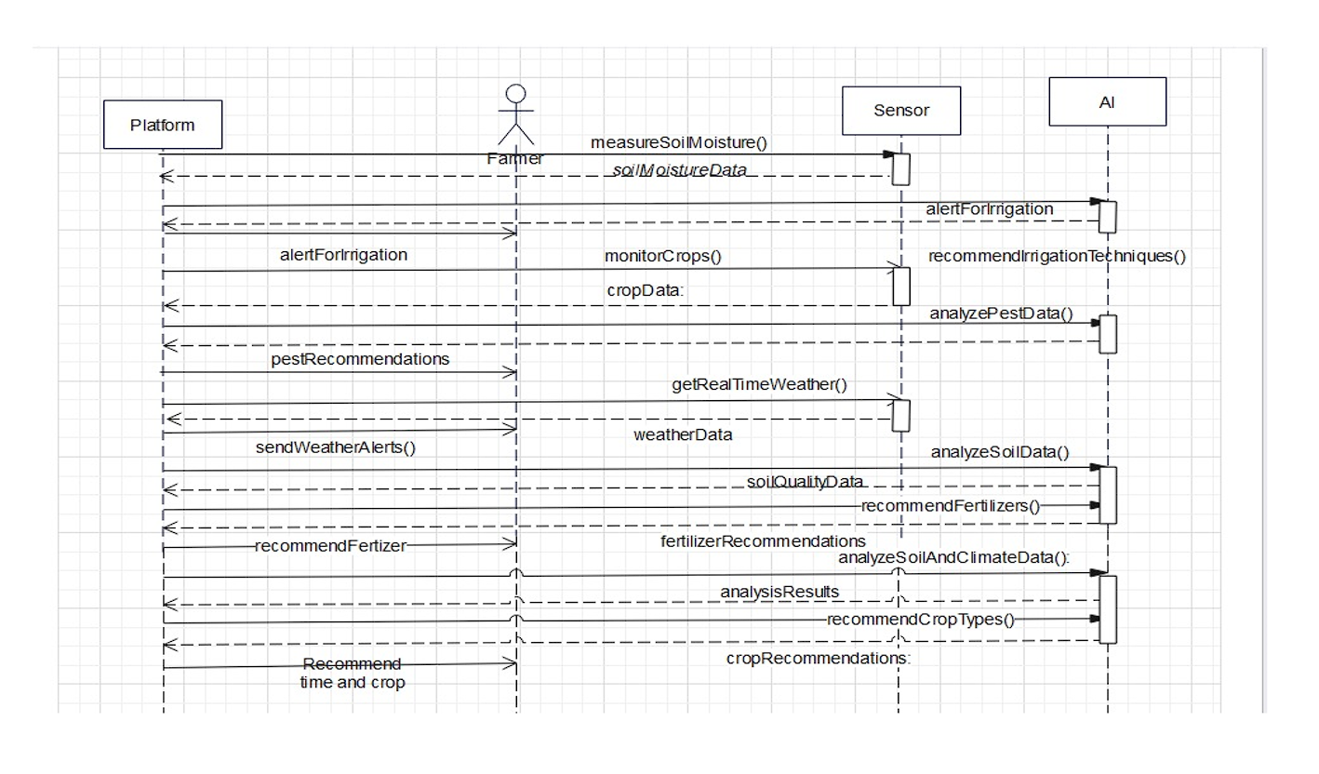

**Analyzing the Provided Sequence Diagram:**

The diagram shows the interactions between four actors in an agricultural context: **Farmer**, **Platform**, **Sensor**, and **AI**.

**Sequence of Events:**

1. **Soil Moisture Measurement:**
   * The **Farmer** initiates the process by requesting to measure soil moisture from the **Platform** using measureSoilMoisture().
   * The **Platform** then requests soil moisture data from the **Sensor** (soilMoistureData).
   * The **Sensor** responds with the soil moisture data back to the **Platform**.
2. **Irrigation Alert and Recommendations:**
   * The **Platform** sends an alert for irrigation to the **AI** (alertForIrrigation).
   * The **AI** processes the data and sends an alert to the **Platform** (alertForIrrigation).
   * The **Platform** relays the alert to the **Farmer**.
   * The **Platform** sends crop data to the **AI** (monitorCrops(), cropData:).
   * The **AI** recommends irrigation techniques to the **Platform** (recommendIrrigationTechniques()).
3. **Pest Analysis and Recommendations:**
   * The **AI** analyzes pest data (analyzePestData()).
   * The **AI** sends pest recommendations to the **Platform** (pestRecommendations).
   * The **Platform** relays the recommendations to the **Farmer**.
4. **Weather Analysis and Alerts:**
   * The **Platform** requests real-time weather data (getRealTimeWeather()).
   * The data is received by the **Platform** (weatherData).
   * The **Platform** sends weather alerts to the **Farmer** (sendWeatherAlerts()).
5. **Soil Analysis and Fertilization Recommendations:**
   * The **Platform** sends soil quality data to the **AI** (soilQualityData).
   * The **AI** recommends fertilizers to the **Platform** (recommendFertilizers()).
   * The **Platform** sends fertilizer recommendations to the **Farmer** (recommendFertilizer).
6. **Comprehensive Analysis and Crop Recommendations:**
   * The **AI** performs a comprehensive analysis of soil and climate data (analyzeSoilAndClimateData(), analysisResults).
   * The **AI** recommends crop types to the **Platform** (recommendCropTypes(), cropRecommendations).
   * The **Platform** provides recommendations on crop type and timing to the **Farmer** (Recommend time and crop).

**Interpretation:**

This Sequence Diagram effectively illustrates the flow of information and actions in a smart agriculture system. It shows how the **Farmer** interacts with the **Platform**, which in turn communicates with the **Sensor** and the **AI** to provide various services. The diagram highlights the role of the **AI** in analyzing data and providing recommendations, as well as the **Platform**'s role in coordinating communication and delivering information to the **Farmer**.

**Key Takeaways:**

* The diagram demonstrates the sequential flow of information in a smart agriculture system.
* It highlights the interactions between the **Farmer**, **Platform**, **Sensor**, and **AI**.
* It shows the role of the **AI** in data analysis and decision-making.
* It illustrates how the **Platform** acts as an intermediary between the **Farmer**, **Sensor**, and **AI**.